**Hospital Management System**

**Report on Sequence Diagram, Activity Diagram, State Chart**

**Submitted by**: **Group 05**

**Student ID**:

1005011, 1005016, 1005019, 1005021, 1005024

**Outline of the report**

* Subsystems
* Use Case Glossary
* Sequence Diagram
* Activity Diagram
* State chart Diagram

**Subsystems**

* Registration
* Patient Management
* Employee Management
* Scheduling
* Billing

**1.Registration System** Use case Glossary

|  |  |  |
| --- | --- | --- |
| Use-case ID>Name | Description | Participant Actors and roles |
| 1.1>Register Patient | PT completes the registration process by giving necessary information to RCP | PT,RCP |
| 1.2>Prepare and View Current Patient List | RCP,AD can see the current patient list | RCP,AD |

**Sequence Diagram 1.1: Register Patient**

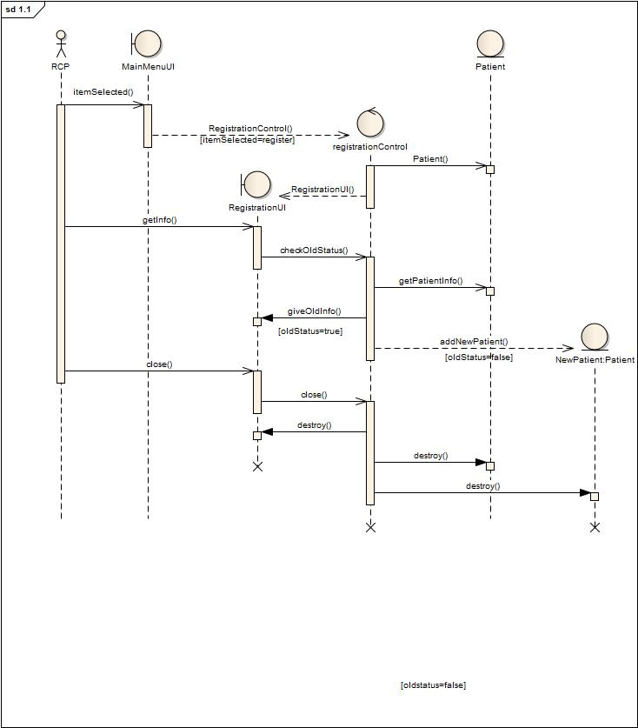

**Activity Diagram 1.1:RegisterPatient**

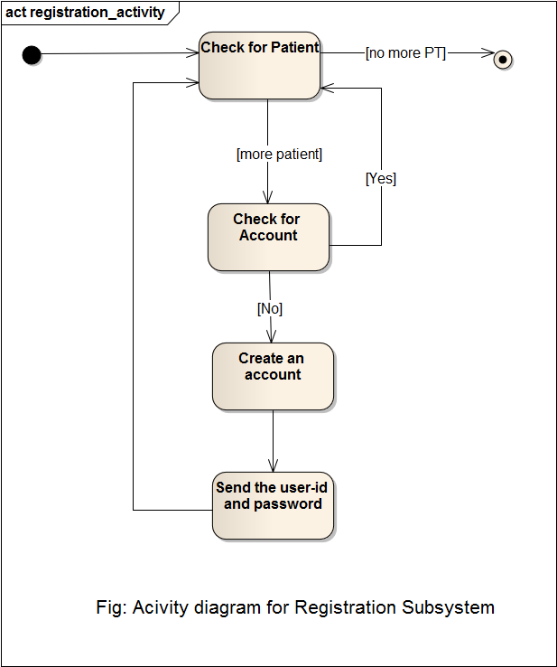

**Sequence Diagram 1.2: Prepare and View Current Patient List**

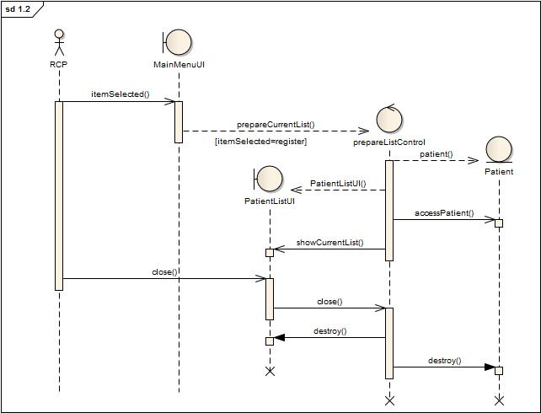

**Activity Diagram 1.2: Prepare Current Patient List**

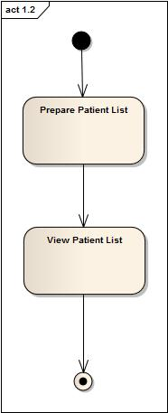

**State Chart of Register Patient Class**

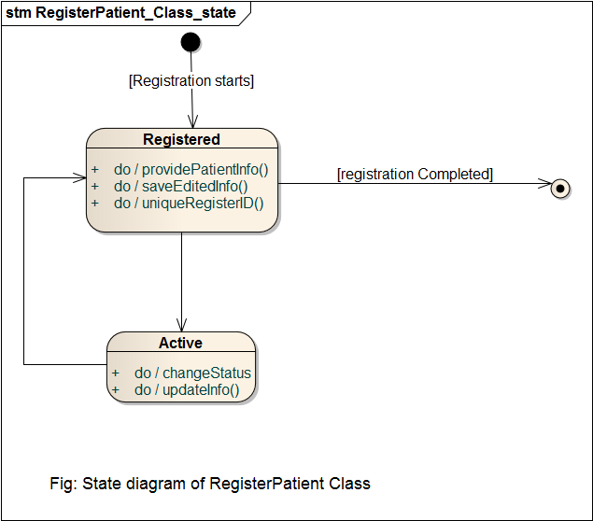

**2. Patient Management**

Use case Glossary

|  |  |  |
| --- | --- | --- |
| Use-case ID>Name | Description | Participant Actors and roles |
| 2.1>Appointment Assign | PT goes to RCP and requests for an appointment, RCP checks the duty schedule of the DOC and makes an appointment | DOC,RCP,PT |
| 2.2>Prepare Prescription | DOC will prepare electronic prescription | DOC |

**Sequence Diagram 2.1: Appointment Assign**

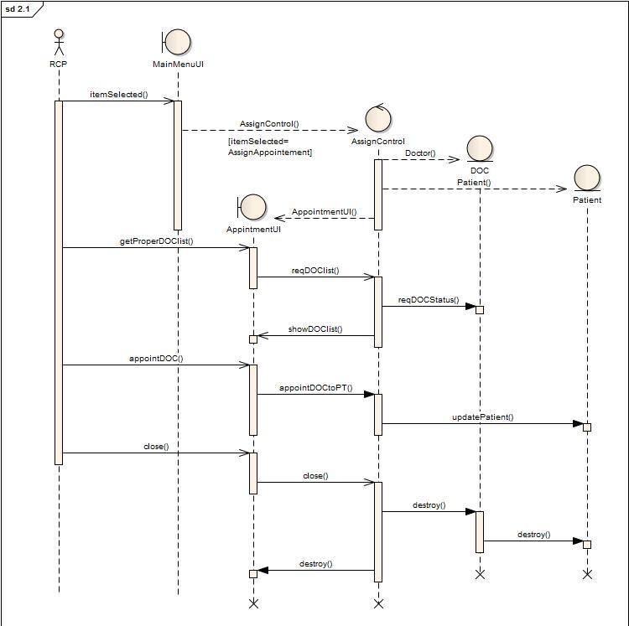

**Activity Diagram 2.1: Appointment Assign**

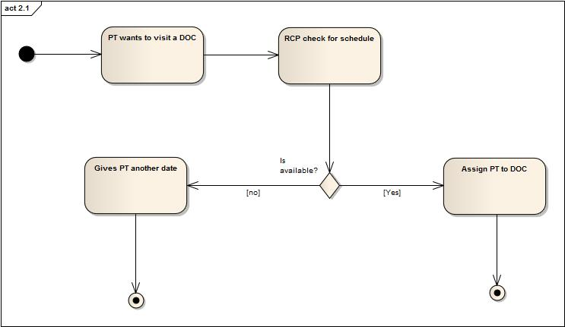

**Sequence Diagram 2.2: Prepare Prescription**

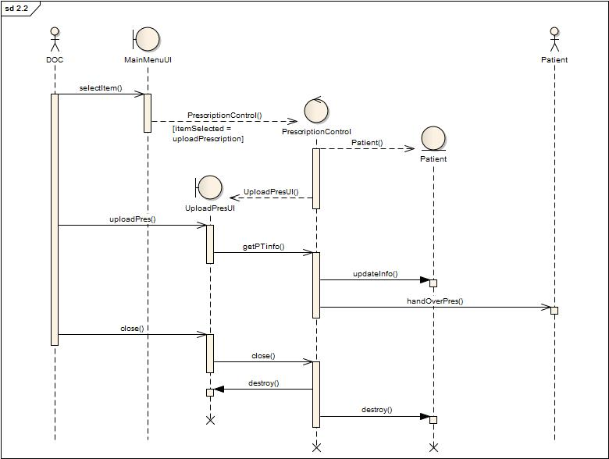

**Activity Diagram 2.2: Prepare Prescription**

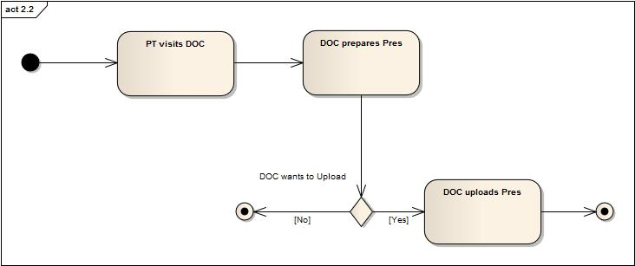

**Sequence Diagram 2.3: Update Patient Database**

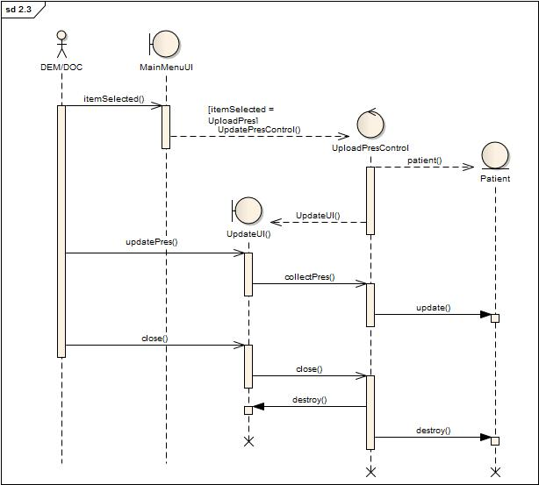

**Activity Diagram 2.3: Update Patient Database**

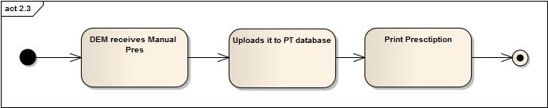

**Sequence Diagram 2.4: Cabin/Bed Assign**

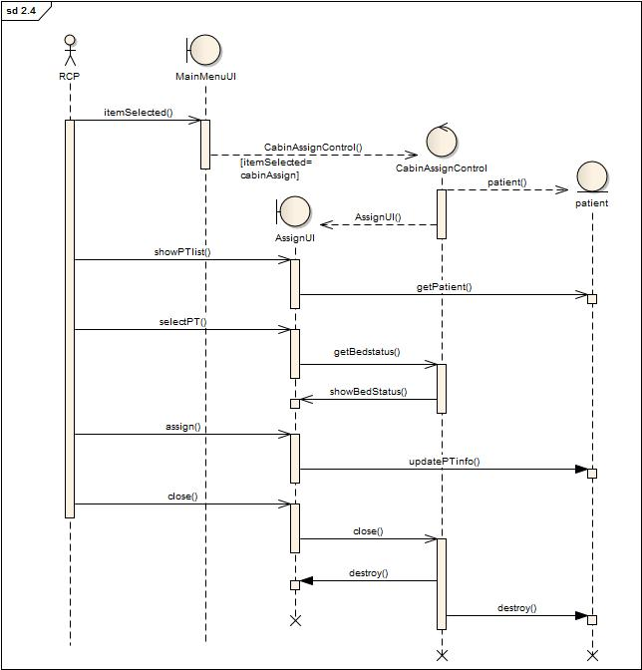

**Acitivity Diagram 2.4: Cabin/Bed Assign**

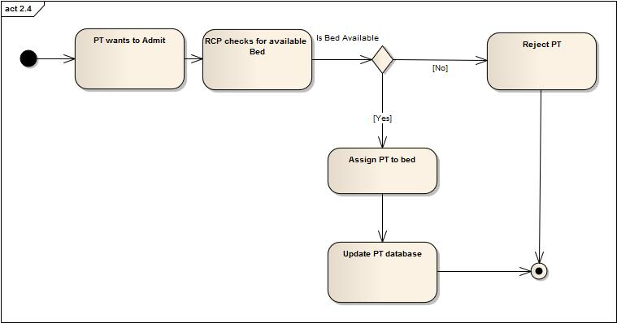

**Sequence Diagram 2.5:Discharge**

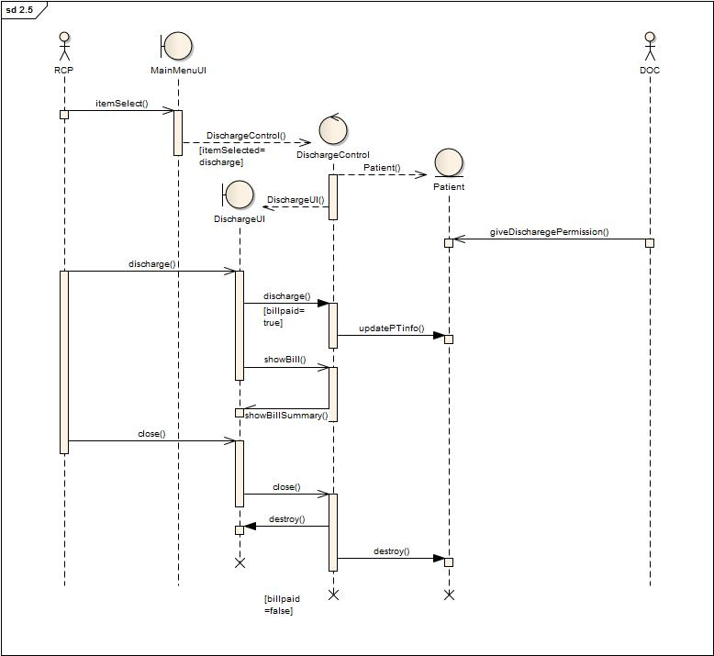

**Activity Diagram 2.5:Discharge**

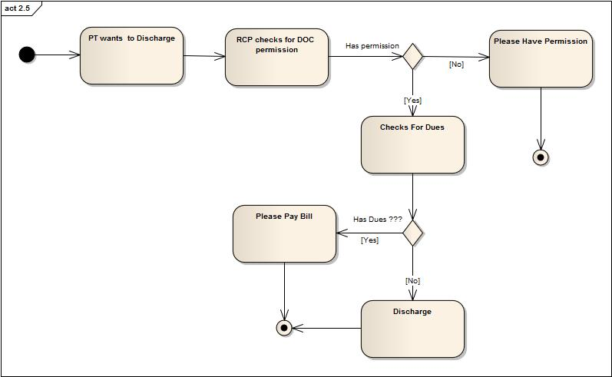

**State Chart of Patient management Subsystem**

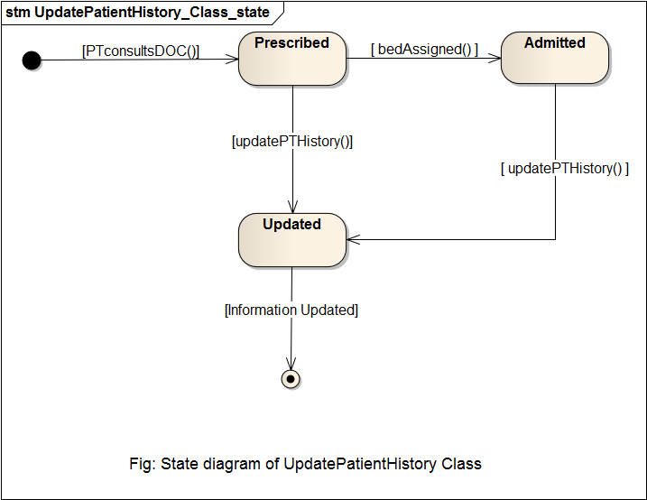

**State chart of Patient management Subsystem**

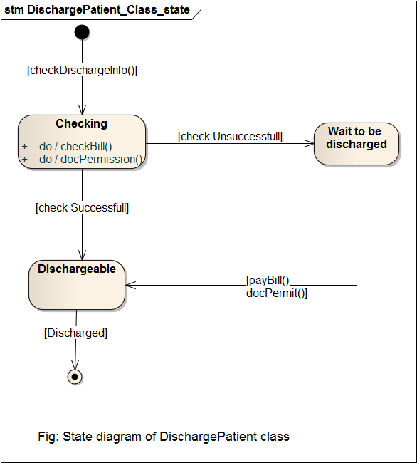

**3. Employee Management**

Use case Glossary

|  |  |  |
| --- | --- | --- |
| Use-case ID>Name | Description | Participant Actors and roles |
| 3.1> Employee Profile Creation | AD creates new employee profile for each employee in the hospital | AD,EMP |
| 3.2>Receive and Distribute Duty Schedule | HRO gets the duty schedule from 6.2 and gives it to the EMP | HRO |
| 3.3>View Employee List | AD can view the employee list | AD |
| 3.4>Update Employee Profile | AD can update employee profile, AD can also fire an employee, AD changes the pay scale salary | AD,EMP |
| 3.5> Leave Management | EMP applies for leave , AD grants/denies thScheduling e request and send it back to Subsystem | AD,EMP |

**Sequence Diagram 3.1 : Employee Profile Creation**

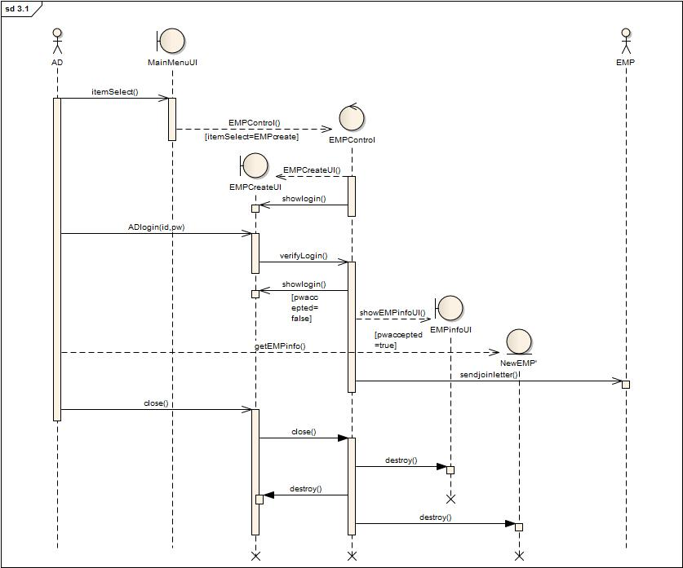

**Activity Diagram 3.1 : Employee Profile Creation**

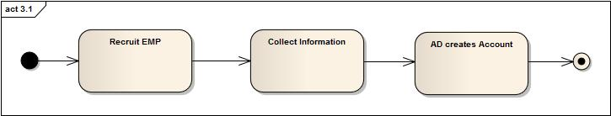

**Sequence Diagram 3.2: Receive and Distribute Duty Schedule**

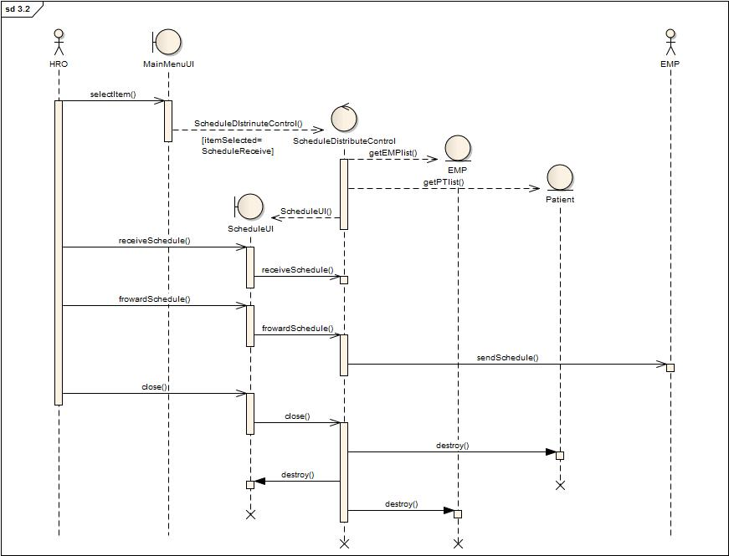

**Activity Diagram 3.2: Receive and Distribute Duty Schedule**

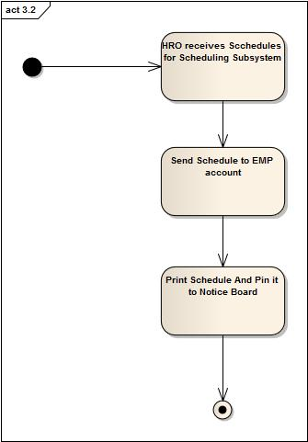

**Sequence Diagram 3.3: View Employee List**

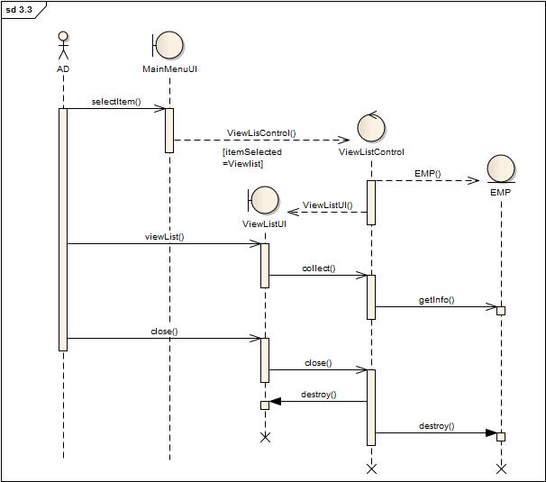

**Activity Diagram 3.3: View Employee List**

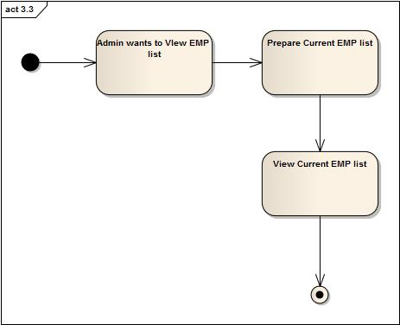

**Sequence Diagram 3.4: Update Employee Profile**

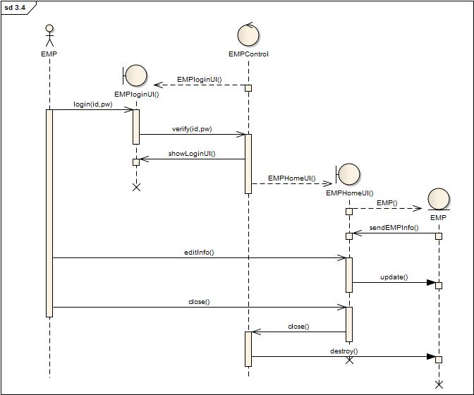

**Activity Diagram 3.4: Update Employee Profile**

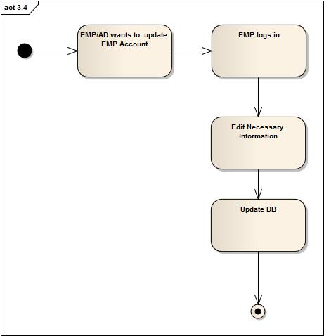

**Sequence Diagram 3.5: Leave Management**

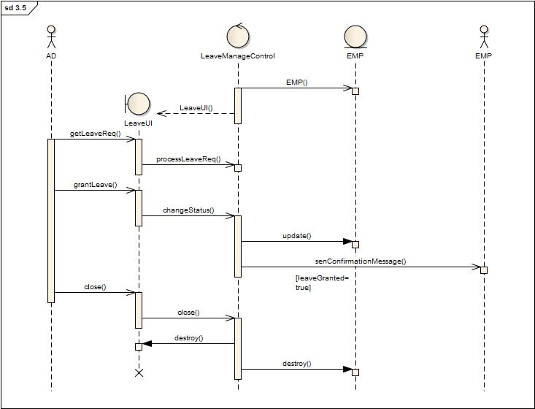

**Activity Diagram 3.5: Leave Management**

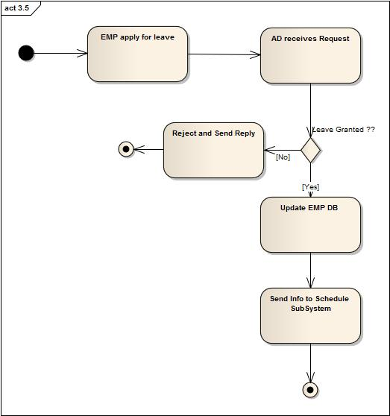

**State Diagram of CreateEmployeeProfile Class**

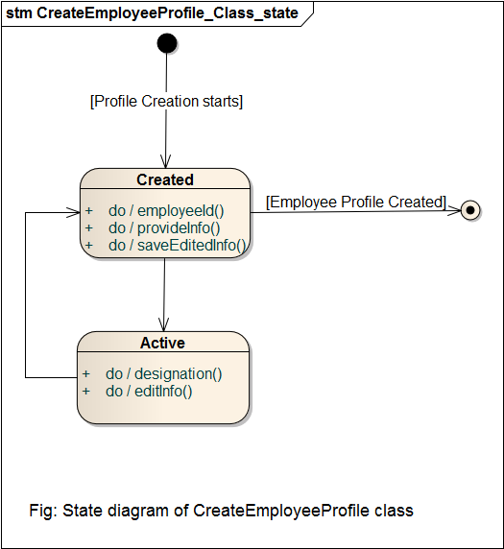

**State Diagram of DistributeEmployeeSchedule Class**

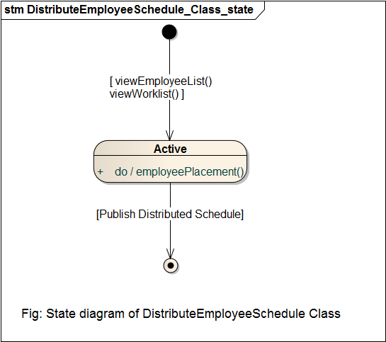

**4. Scheduling System**  
 Use case Glossary

|  |  |  |
| --- | --- | --- |
| Use-case ID>Name | Description | Participant Actors and roles |
| 4.1>Get Active Employee List | AD gets the active employee list | AD |
| 4.2>Duty Schedule | AD specifies duty schedules of all employees | AD |

**Sequence Diagram 4.1: Active Employee List**

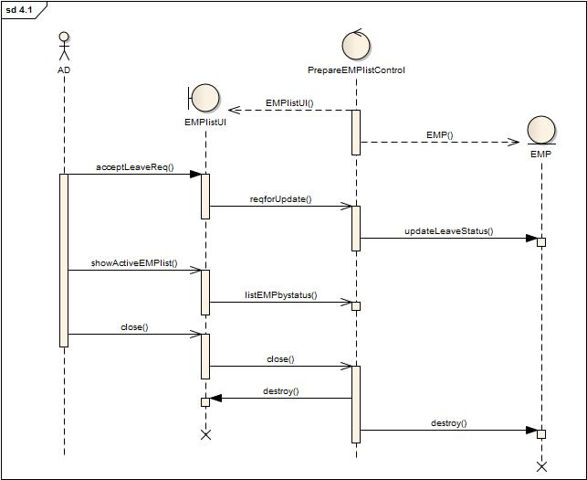

**Activity Diagram 4.1: Active Employee List**

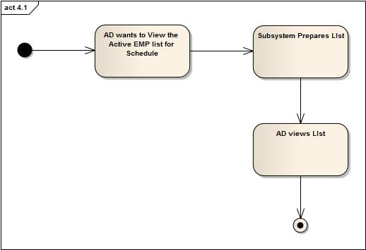

**Sequence Diagram 4.2: Duty Schedule**

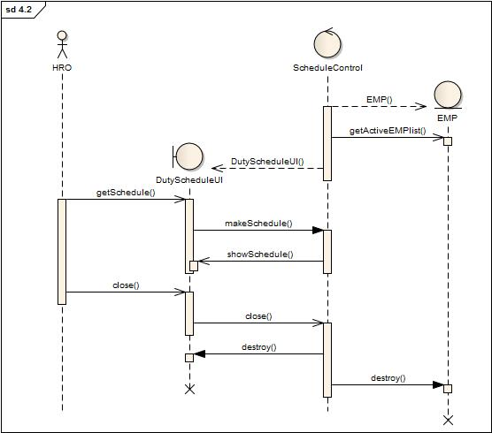

**Activity Diagram 4.2: Duty Schedule**

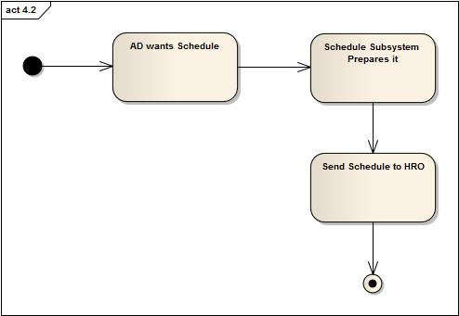

**5. Billing System**   
 Use case Glossary

|  |  |  |
| --- | --- | --- |
| Use-case ID>Name | Description | Participant Actors and roles |
| 5.1>Collect Bill Information | CLK collects all billing information from different sub system | CLK |
| 5.2>Receive bill | PT gives total bill to CLK | PT,CLK |

**Sequence Diagram 5.1:Collect Bill Information**

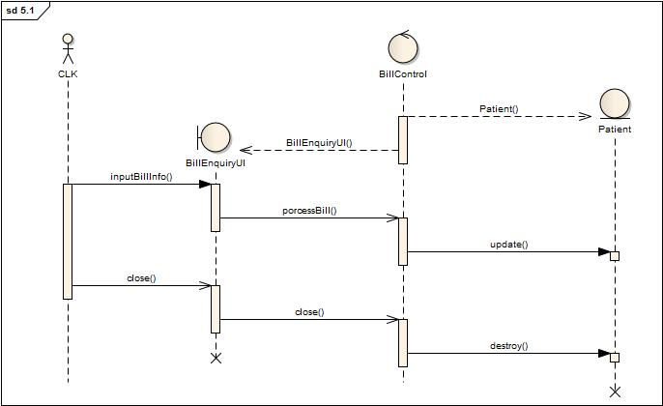

**Activity Diagram 5.1:Collect Bill Information**

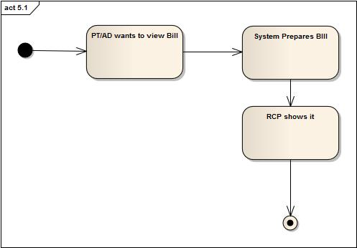

**Sequence Diagram 5.2: Receive Bill**

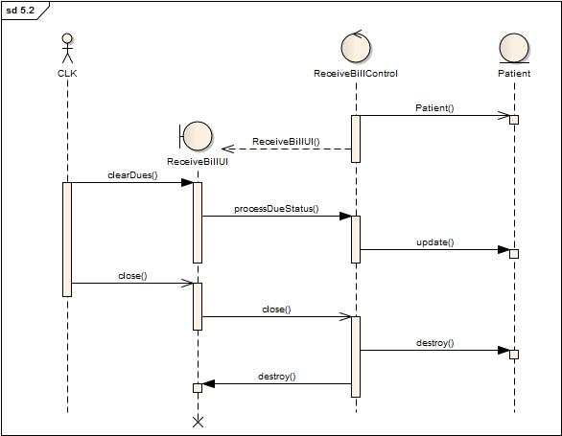

**Activity Diagram 5.2: Receive Bill**

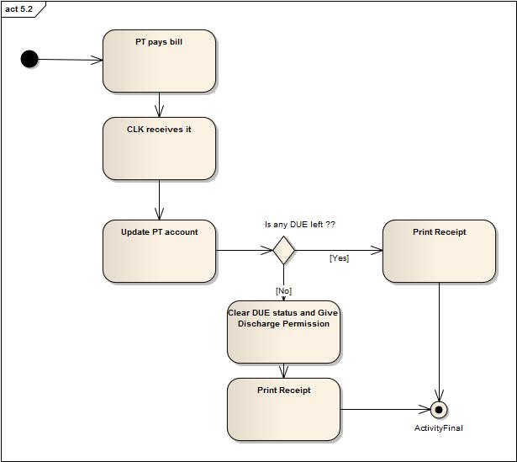

**State Diagram of PrepareBill Class**

